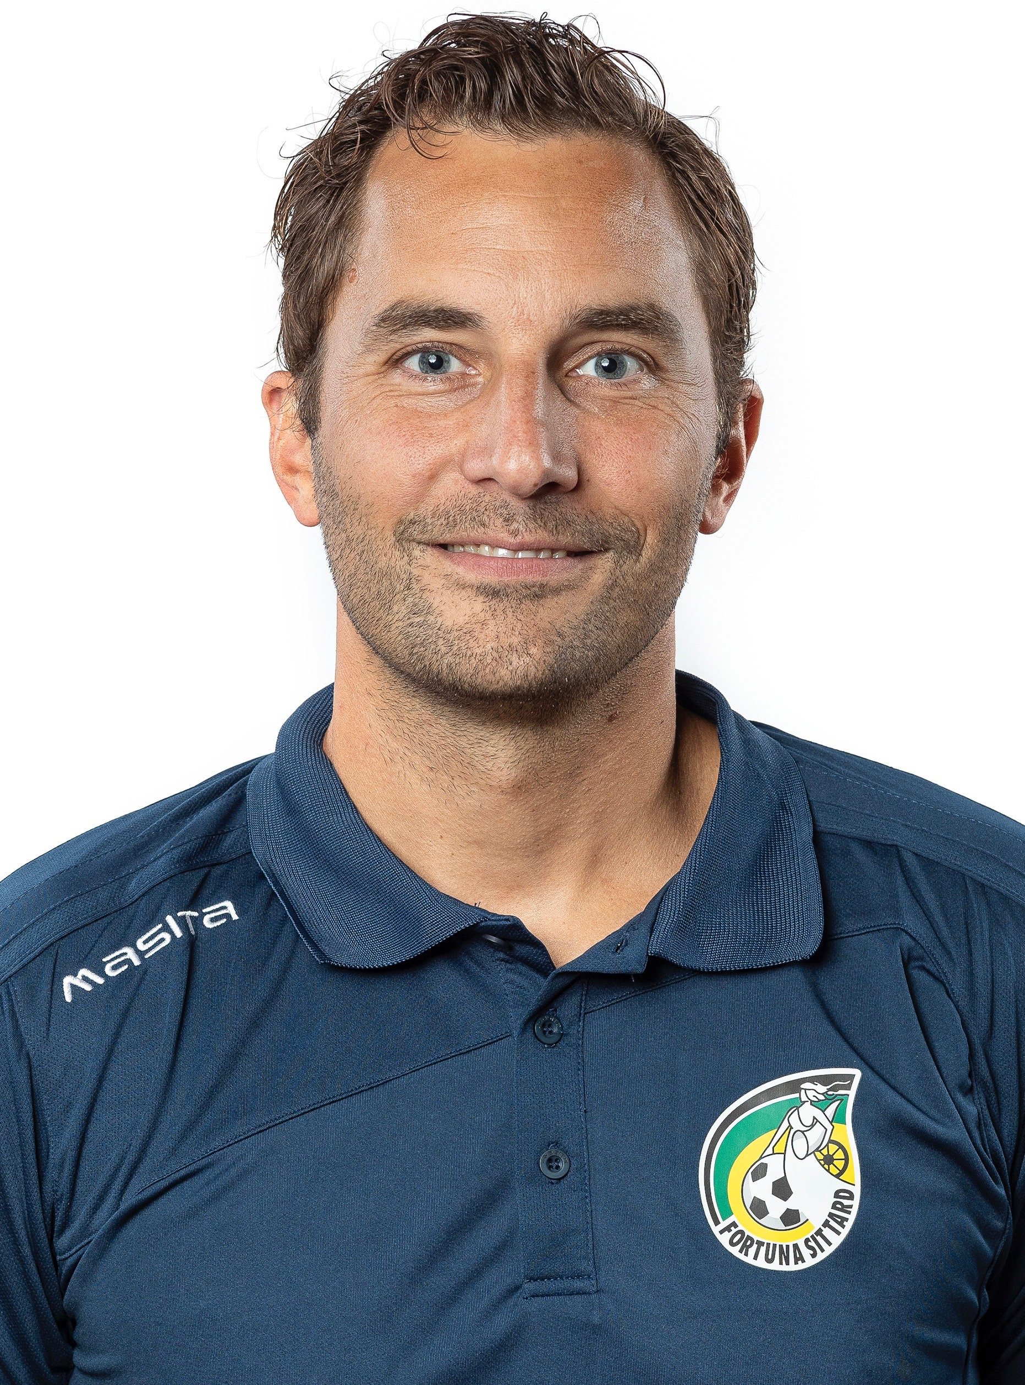

Name: Niels Nielen
Adres: Sperwerstraat 21
Zip code and residence: 5804 VC Venray (The Netherlands)
Date of birth: 25-08-1982
Phone number: 00316-53537165
Email: njenielen@gmail.com

Summary

I am a young, professional, enthusiastic and ambitious goalkeeper coach in professional football in The Netherlands. It is my dream and my ambition to work (abroad) as goalkeepercoach in international football.
I am experienced in setting up and monitoring development programs and development plans for goalkeepers of the first team and for goalkeepers in the age from 9 till 23. Thereby I am beware of the importance of good communication to managers, coaches, goalkeepers and other departments of the club.
Working with high standards and create a positive environment for players, coaches, other colleagues and myself is the way I am used to work.

Education

2019 – 03/2020: UEFA C
2019: Clinic Goalkeepercoaching AJAX Coaching Academy
2018: PEAK International Goalkeeping Conference
2018: ProGoal Keepercoach (Maarten Arts)
2017: Keepercoach UEFA B (KNVB, Dutch Soccer Federation)
2016: Keepercoach UEFA C (KNVB, Dutch Soccer Federation)
2009: BSc. SPECO (Sports Economics & Communication)

Languages

Dutch: mother tongue
English: good in speaking and writing
German: reasonable speaking

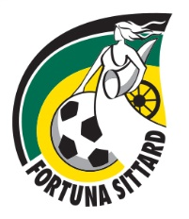
Activities as goalkeepercoach

2019 – today: Assistant Goalkeepercoach 1st team / Lead Academy Goalkeepercoach (u.23, u.19, u.17, u.15, u.13, u.11, u.10) at Fortuna Sitard


2017 – today: Internships / workshops at 1st teams of

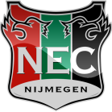

Fortuna Sittard Zaglebi Lubin Bayer Leverkusen N.E.C. Nijmegen


2017 – today: Internships / workshops at academies of
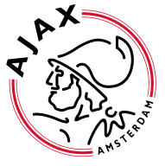


AJAX Amsterdam PSV Eindhoven Bayer Leverkusen Zaglebie Lubin Club Brugge




Borussia Dortmund Liverpool F.C. U.23 Arsenal

2017 – 2019: Goalkeepercoach at youth academy N.E.C. Nijmegen (u.19, u.17, u.15, u.13,
u.11, u.10, u.9)


2015 – 2018: Goalkeepercoach PSV Eindhoven Soccerschool

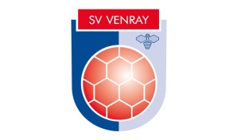
2016 – 2018: Goalkeepercoach at SV Venray 1st and 2nd team(1st division amature and head
division amature) and u.19

2014 – 2018: Goalkeepercoach at SV Venray Youth Academy, also member of the technical
team to optimize the collaboration between goalkeepercoaches and team
coaches. Responsible for improving the other goalkeepercoaches.


2006 – 2007: Goalkeepercoach at Progoal goalkeeperacademy Netherlands and Germany

2005 – 2006: Goalkeepercoach at Progoal goalkeeperacademy Netherlands

Activities as goalkeeper

2014 – 2016: SV Venray (1st division amature)
2008 – 2014: SV Venray (head division semi professional)



2005 – 2008: JVC Cuijk (head division semi professional, champion in 2007)

2002 – 2005: SV Venray (2nd division amature, champion in 2005)

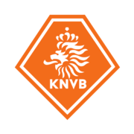
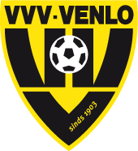
2001 – 2002: VVV-Venlo 1 (first division professional)
1992 – 2001: VVV-Venlo Youth Academy, during this period selected for the
Dutch National Team u.17

