***Marko Božović***

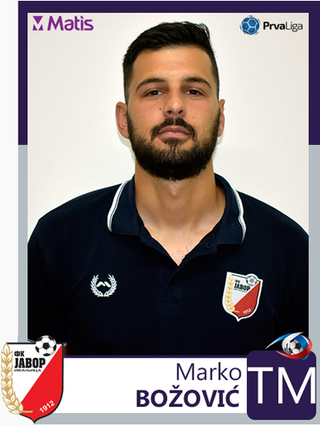 UEFA A Licenced Football Coach

Master professor of Sport and Physical Education

*Date of birth*: 30.07.1992

*Place of birth*: Ivanjica, Serbia

*Languages*: Serbian, English

*Adress*: Prilicki Kiseljak, 32252

*Email*: [bozovic1992@gmail.com](mailto:bozovic1992@gmail.com)

*Phone*: +381 64 410 73 10

***Coaching Qaulifications*:**

* Holder of UEFA A licence
* Graduated and Mastered on Faculty of Sport and physical education, University of Belgrade

***Coaching career summary*:**

* FK DIF – coach of U-10
* FK DIF – coach of U-14
* FK Vizura – Coach of U-10
* AF Nemanja Matić – Coach of U-12
* FK Rakovica – First team Assistan Coach
* FK Javor Matis – First team Assistan coach
* FK Javor Matis – Head of youth development (make many national team players)
* FK Javor Matis – Sporting director (win promotion to Serbian Superleague)

***Key skills and competencies*:**

* Highly skilled implementing bespoke coaching strategies designed around a club’s existing team and future objectives.
* Possesses an exceptional track record in helping players realize their potential, working with each player as an athlete and person to instill a professional attitude and ensure they’re prepared for the rigours of professional football.
* An excellent communicator who is able to confidently liaise across all levels from youth team to the board.
* Accept a high degree of responsibility in a team’s success and provides a figurehead that players and staff look in times of difficulty.
* I am comfortable working with multiple systems to suit the capabilities of the players worked with.
* I have ability to quickly adapt to new environment and understand the specific cultural differences and preferred training styles of the players.
* I always looking to improve myself, always looking forward to the new knowledge.

***Notable players and coaches with whom I worked*:**

* Albert Nadj – former Serbia national, 47 caps.
* former player of Partizan, Betis, Oviedo, Rostov and Čukarički.
* Srdjan Vasiljević – former Red Star Head of youth development.

-Serbian national team assistant manager.

-Angola national team manager.

* Vlado Jagodić – former Bosnia and Hercegovina U-21 manager.

-former FK Borac Banja Luka manager.

* Vuk Mitošević – FC Vojvodina player, former Serbian U-17, U-19, U-21.
* Miloš Karišik – FK Krupa player, former Serbian U-17, U-19.
* Aleksa Amanović – FK Javor Matis, FYROM U-21.
* Alija Krnić – FK Javor Matis, Montenegrian U-19, U-21.

-best young player of Montenegro for 2017.

* Derek Cornelius – FC Vancuver Whitecaps, Canadian national.

-best young player of Canada for 2018.

* Filip Ivanovski – FK ROPS, former FYROM national.
* Filip Ristovski – FK Shkupi, former FYROM U-21.
* Stefan Panić – FK Riga, former Serbia national.
* Boban Djerić – FK Javor Matis, former Bosnia and Hercegovina U-17, U-19.
* Dino Dolmagić – FK Javor Matis, former Serbia U-19.
* Romeni Scott Bitsindou – FC Lommel, former Congo U-20.
* Nemanja Šćekić – FK Zemun, former Montenegro U-21.