**Salvatore Pappalardo Curriculum Vitae**

**+86 15044807568**

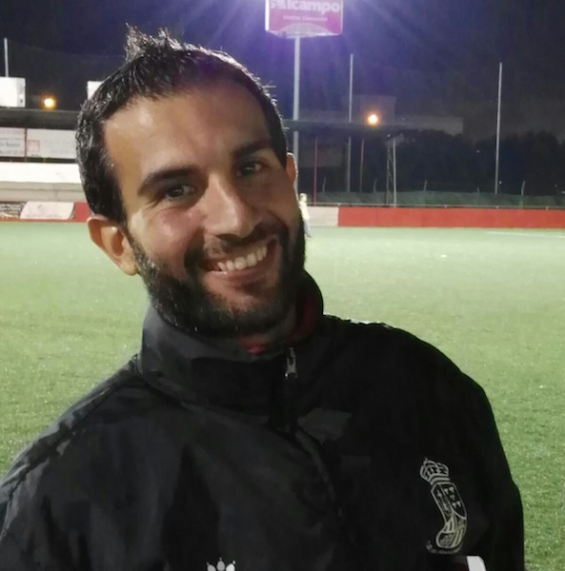

**+39 3357415309**

**pappalardosalvo@live.it**

**PERSONAL PROFILE**

Human Resources professional, specialist in training and development. *Quiet leadership* and flexibility, wont to international environment. Reliable, proactive and polyhedral.

**PLAYER EXPERIENCE**

**98/99 Acireale Calcio - Serie C1 – U14 - Goalkeeper**

**99/00 Acireale Calcio – Serie C2 – U15 - Goalkeeper**

**00/01 Acireale Calcio – Serie C2 – U17 - Goalkeeper**

**01/02 Acireale Calcio – Serie C2 – U17 - Goalkeeper**

**02/03 Acireale Calcio – Serie C2 – U19 - Goalkeeper**

**Jan. 03 Giarre Calcio – First team (Eccellenza) – Goalkeeper**

**03/04 Aci Sant’Antonio – First team (Eccellenza) – Goalkeeper**

**04/05 Aci Sant’Antonio – First team (Eccellenza) – Goalkeeper**

**05/06 Santa Venerina – First team (Prima Categoria) – Goalkeeper**

**06/07 No team– Erasmus European Project (Madrid)**

**07/08 Novoli (Firenze) – First team (Seconda Categoria) – Midfielder**

**08/09 Città di Castello (Firenze) – First team (Terza Categoria) – Goalkeeper**

**09/10 No team – European Project Mae-Crui, italian Embassy (Budapest, Hungary)**

**10/11 Città di Acireale – First team (Promozione) – Goalkeeper**

**11/12 The Magdalenians (London) - Amatorial football team - Midfielder**

**COACHING HISTORY**

**Bayannur Sports School (Bayannur, China) 15/08/18 - 03/07/19**

**Supervisor Coach**

Planning learning and development targets

Delivering smooth training coaching sessions

Overlook to other coaches

Delivering in class sessions using e-learning tools

**Sd Sp. Viagrande, (Catania, Italy) 01/07/17 – 30/04/18**

**First team Assistant Coach**

**U19 Coach**

Team and talent management

Dealing with conflicts, teamwork and leadership

Planning learning and development targets

Delivering smooth training coaching sessions in order to achieve the targets and club’s vision

Match and opponent analysis

**Club Deportivo San Francisco, (Mallorca, Spain) 01/07/16 – 30/06/17**

**U14 Coach**

**U19 Assistant Coach**

Team and talent management

Dealing with conflicts, teamwork and leadership

Planning learning and development targets

Delivering smooth training coaching sessions in order to achieve the targets and club’s vision

Match and opponent analysis

**Calcio Catania S.p.a. (Catania, Italy) 01/07/14 – 30/06/16**

**U15 Coach 2014/15**

**U17 Coach 2015/16**

Team and talent management

Dealing with conflicts, teamwork and leadership

Planning learning and development targets

Delivering smooth training coaching sessions in order to achieve the targets and club’s vision

Match and opponent analysis

E-learning and audiovisual trainings

**Football Club Acireale Calcio, Academy (Acireale, Italy) 19/08/12 – 30/06/14**

**U12 Coach 2012/13**

**U15 Coach 2013/14**

Team and talent management

Dealing with conflicts, teamwork and leadership

Planning learning and development targets

Delivering smooth training coaching sessions in order to achieve the targets and club’s vision

Match and opponent analysis

E-learning and audiovisual trainings

**EMPLOYMENT HISTORY**

**Primiceri Editore, Italy 2016**

**Author of the book *Elementi di* *Psicologia Dinamica***

**Millennium Gloucester and Baileys Hotels (London, United Kingdom)**

**HR Assistant 01/06/11 – 01/06/12**

First point of contact for enquiries to the HR Department (telephone / walk in)Updating the staff notice board on a regular basis

Completing all starter paperwork and to liaise with payrollGetting references for new starterscompleting all starter inputting data by ITrent Preparing advertsScreening candidates and short list themInterviewing by telephoneOrganising second interviewsUpdating the hotel vacancy list weeklyPreparing contracts, offer letters and other administration as requiredPreparing ad hoc and regular reports as requested (monthly HR report pack / HOD report pack)Maintaining Kronos Time Management systemSending out probationary review remindersCompleting new starter paperwork on first day

Assisting in best practice HR communications to all internal departmentsAssisting with H.R. projects as directed by the HR Manager / Officer

**La Moderna Agricoltura S.R.L (Catania, Italy)**

**HR Specialist 01/01/10 – 31/05/11**

Restructured the organization chart while improving the communication flow between departments

Created and managed all the recruitment tools

Created the personnel files system as well as all policies and procedures Created and managed all the Recruitment Tools.

**Italian Embassy in Budapest (Budapest, Hungary)**

**Economic Office Intern 03/05/10 – 03/08/10**

First point of contact for enquiries to the Economic Department

Preparing ad hoc and regular reports as requested Assisting with embassy projects as directed by the embassador

**EDUCATION**

**PSYCHOLOGY BACHELORS DEGREE 2012 – 2016**

Scienze e Tecniche PiscologicheUniversità degli Studi di Firenze – Facoltà di Psicologia, Florence, Italy

**COACHING COURSE 2012 – 2013**

Master Executive Coaching EEC – Torino - Roma

**HUMAN RESOURCES MASTERS DEGREE 2007-2009**

Scienze Aziendali, Direzione del personale

Universita’ Degli Studi di Firenze – Facolta’ di Economia, Florence, Italy

**French Course and Portuguese Course** **2008**-**2009**

**BUSINESS ADMINISTRATION BACHELORS DEGREE 2003-2007** Economia Aziendale

Universita’ degli Studi di Catania – Facoltà di Economia, Catania, Italy

**Erasmus European Project 2007**

Universidad Autonoma de Madrid, Madrid, Spagna

**ENGLISH LANGUAGE CERTIFICATE 2003**

Padua College, Brisbane, AustraliaStudent Exchange Program

**LANGUAGES**

English, Spanish, French, Portuguese and Italian as native.

**TRAININGS**

Executive Coaching, EEC (Jan 2013)

UEFA B Coaching Licence (Nov 2012)

Human Resources Management and Leadership Course (June 2006)

First AID and BLSD (2012)

Salvatore Pappalardo