<https://www.sportsjoe.ie/football/need-stop-discriminating-small-technical-player-197206>

[www.nlfaofficial.com](http://www.nlfaofficial.com)

# PERSONAL DETAILS

## Name: Mokhtar Addani

Age: 48years

Nationality: Irish /Algerian

Status: married

Children: 3

Diploma: Engineer in Micro-electronic

UEFA ‘A’ LICENCE

PRO Licence in process

### CONTACT INFORMATION

## Address: 18 Oakdale Drive, Ballycullen, D24, Dublin Ireland

Telephone: +353874444727/+353852574763

E- mail: [addanim@hotmail.com/](mailto:addanim@hotmail.com/) [Sdfapro@gmail.com](mailto:Sdfapro@gmail.com) www.nlfaofficial.com

### EDUCATIONAL BACKROUND

University S.B.A- Microelectronique engineering graduation

-Irish Football Association Elite Pro Licence

-Scottish UEFA ‘A’ Licence

### DIPLOMAS

Elite Pro

UEFA A licence Soccer SFA

UAFA B licence Soccer SFA

Child protection Soccer

Adult Coaching

Youth licence

FA coaching

Referee Cert

Scottish Adult Coaching

### COURSES ATTENDED

* Soccer Coaching
* Soccer development programmer
* Soccer analyser
* Soccer Academy Management
* Soccer talent Development
* Youth licence
* Adult Coaching
* Soccer winning philosophy
* Soccer Events Programming
* Indoor Soccer Development
* Youth Programmes with The Football Association

#### EMPLOYMENT HISTORY

1998-2000 Soccer Coaching in Maardou (Est)

2001-2002 St Annet’s FC Dublin

2003-2005 Clonskeaght United Dublin

2006-2007 St James FC and Clonskeaght Crescent

2006-2008 Foundation of Fast Ireland Soccer School (FISS)

2009-FISS and Cabenteely United

2010-FISS and Mount Merrion Soccer Academy

2010-2011: Joey’s Soccer academy, Mount Merrion U17, and Managing the FISS Academy

2011- 2015 Joey's Academy Head Coach. Founder of the SDFA PRO academy

2016 to Now Director of development Wexford Youth FC

2017 to now managing director National League Football Academy NLFA

#### LANGUAGE SKILLS

- Arabic

* Estonian
* Russian
* English
* French

#### OTHER SKILLS

* Tournaments supervising and programming
* Planning and Developing soccer programs programmes
* Talent Development
* Coaching the Coaches program
* Match Analyses
* Soccer season planning
* Youth Development programming
* Senior Teams programming coaching
* Senior Team preseason managing and coaching
* Clubs Developing philosophy
* Clubs Academy managing and developing
* Clubs Facilities management
* Professional Academies managing and setting up programs

Hobbies- football, travelling, reading

#### REFEREES

-Des Tomllinson: Irish Football Association +353-868590524

-Pat O’connor: Mount Merrion +353-872411438

-Jeff Berlligton: SDFA Academy +353-864056641

-Donald Park SFA / [Donald.park@scotishfa.co.uk](mailto:Donald.park@scotishfa.co.uk)

-Jim Fleeting SFA/ [Jim.Fleeting@scottishfa.co.uk](mailto:Jim.Fleeting@scottishfa.co.uk)

-John Yogi Hughes Inverness manager/ [Yogi@yogi5.co.uk](mailto:Yogi@yogi5.co.uk)

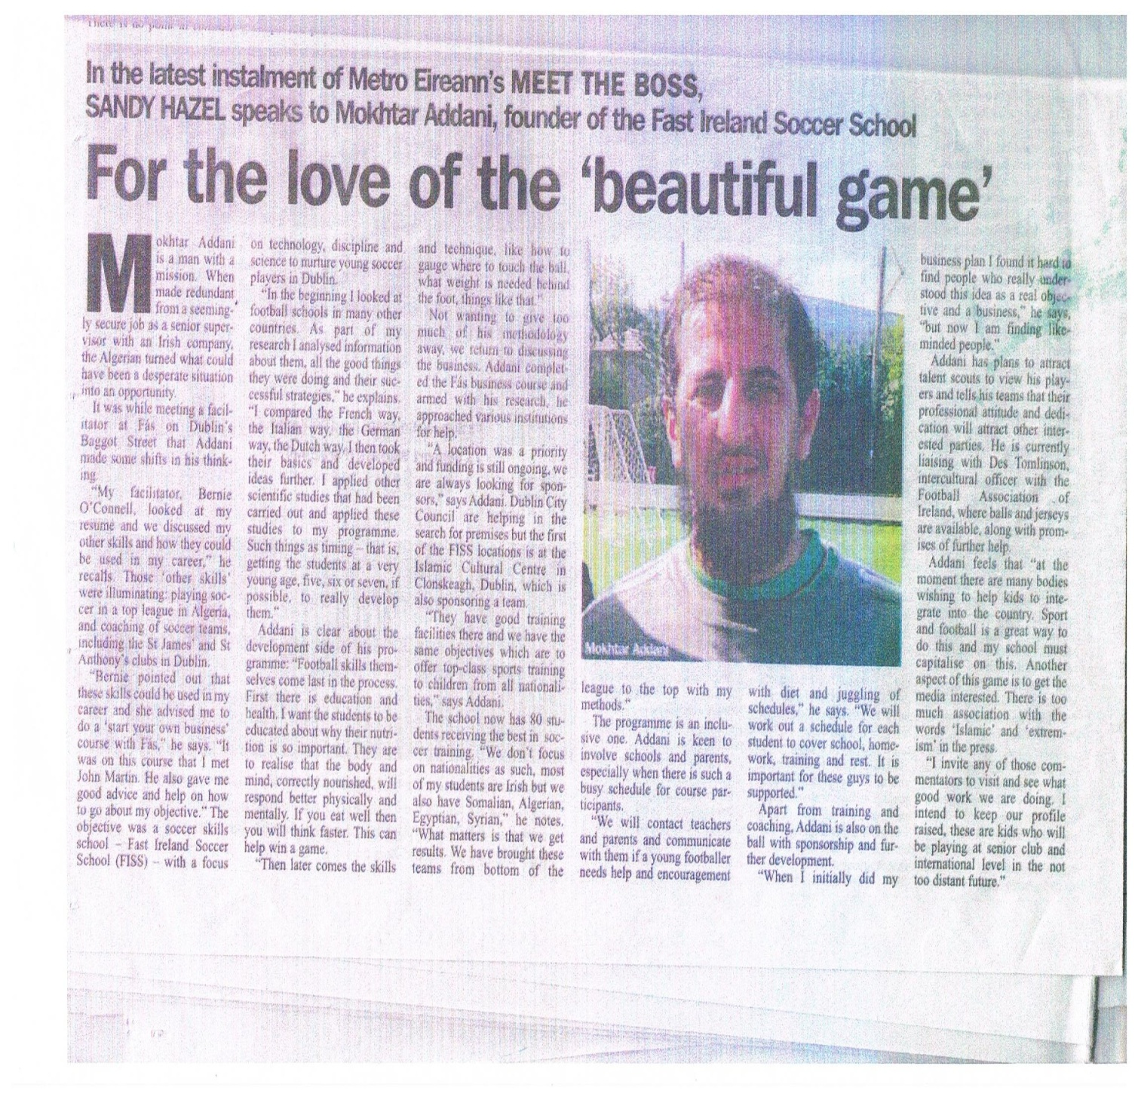

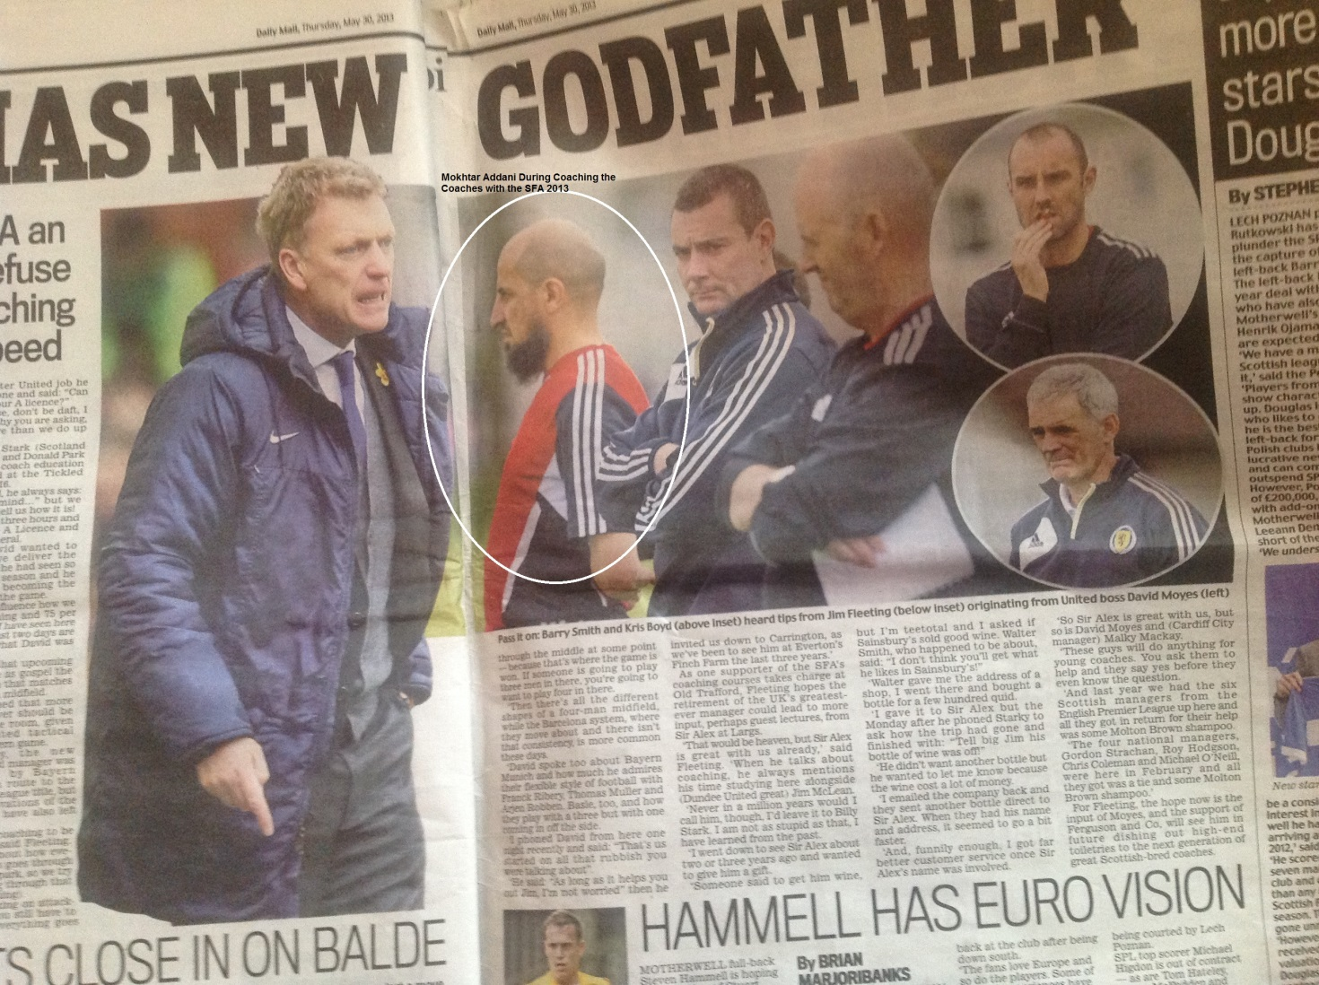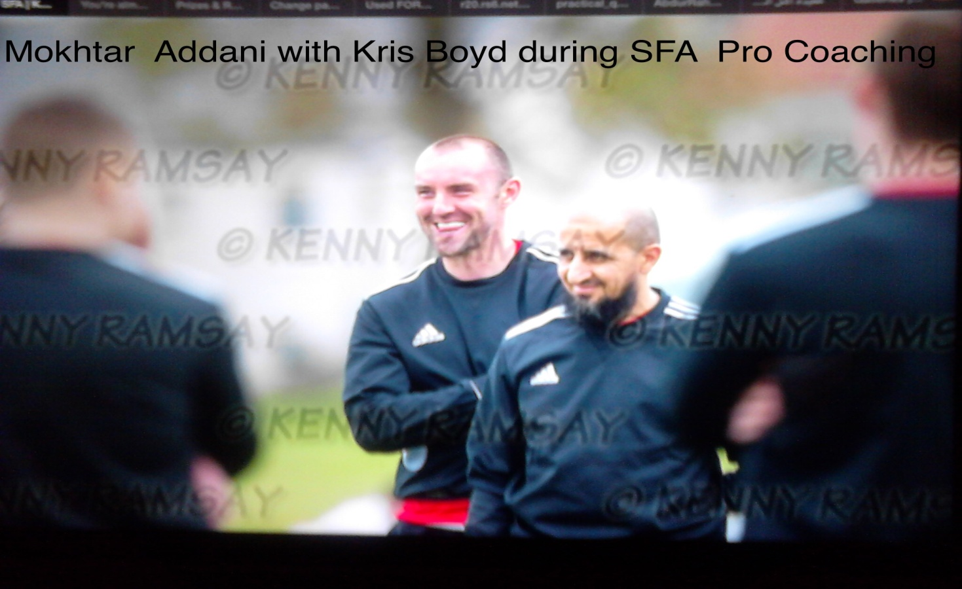

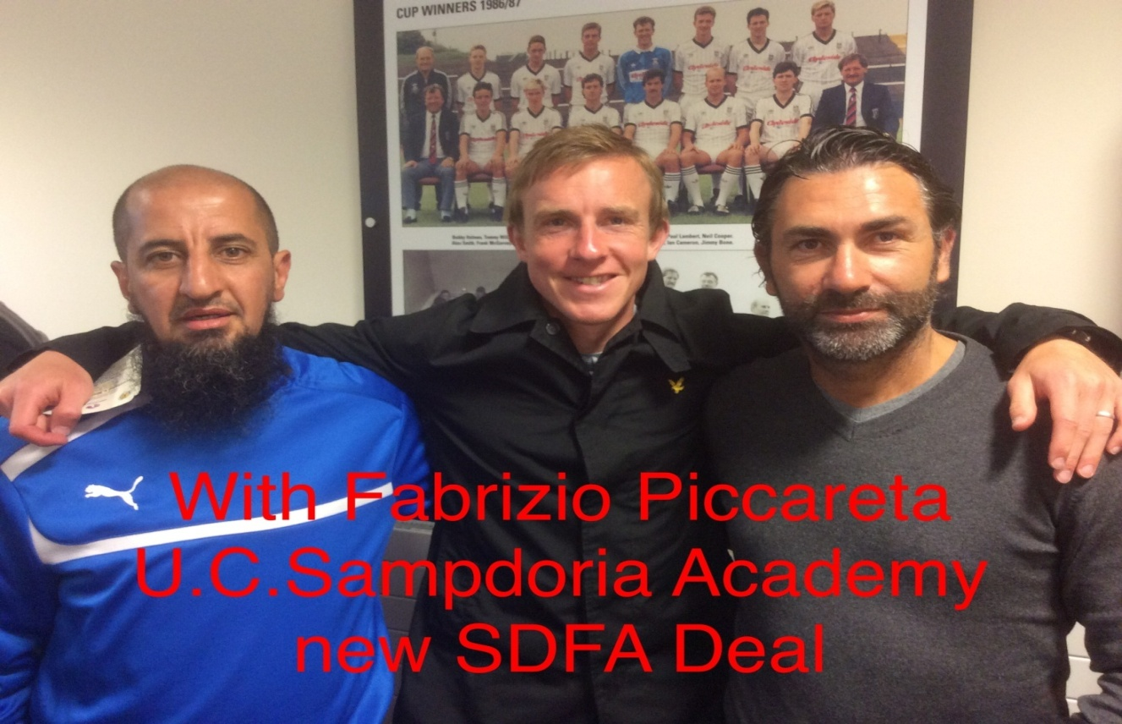

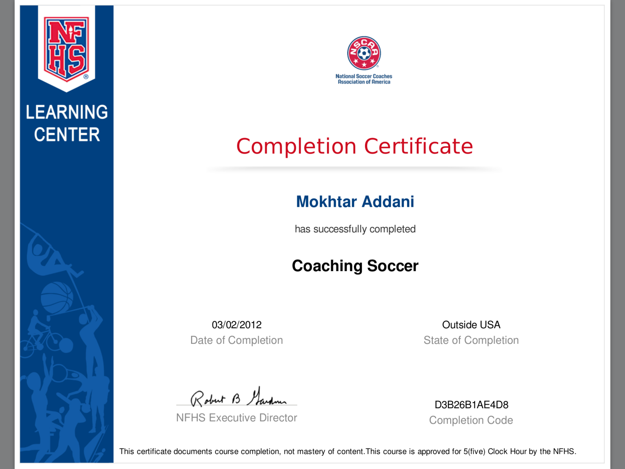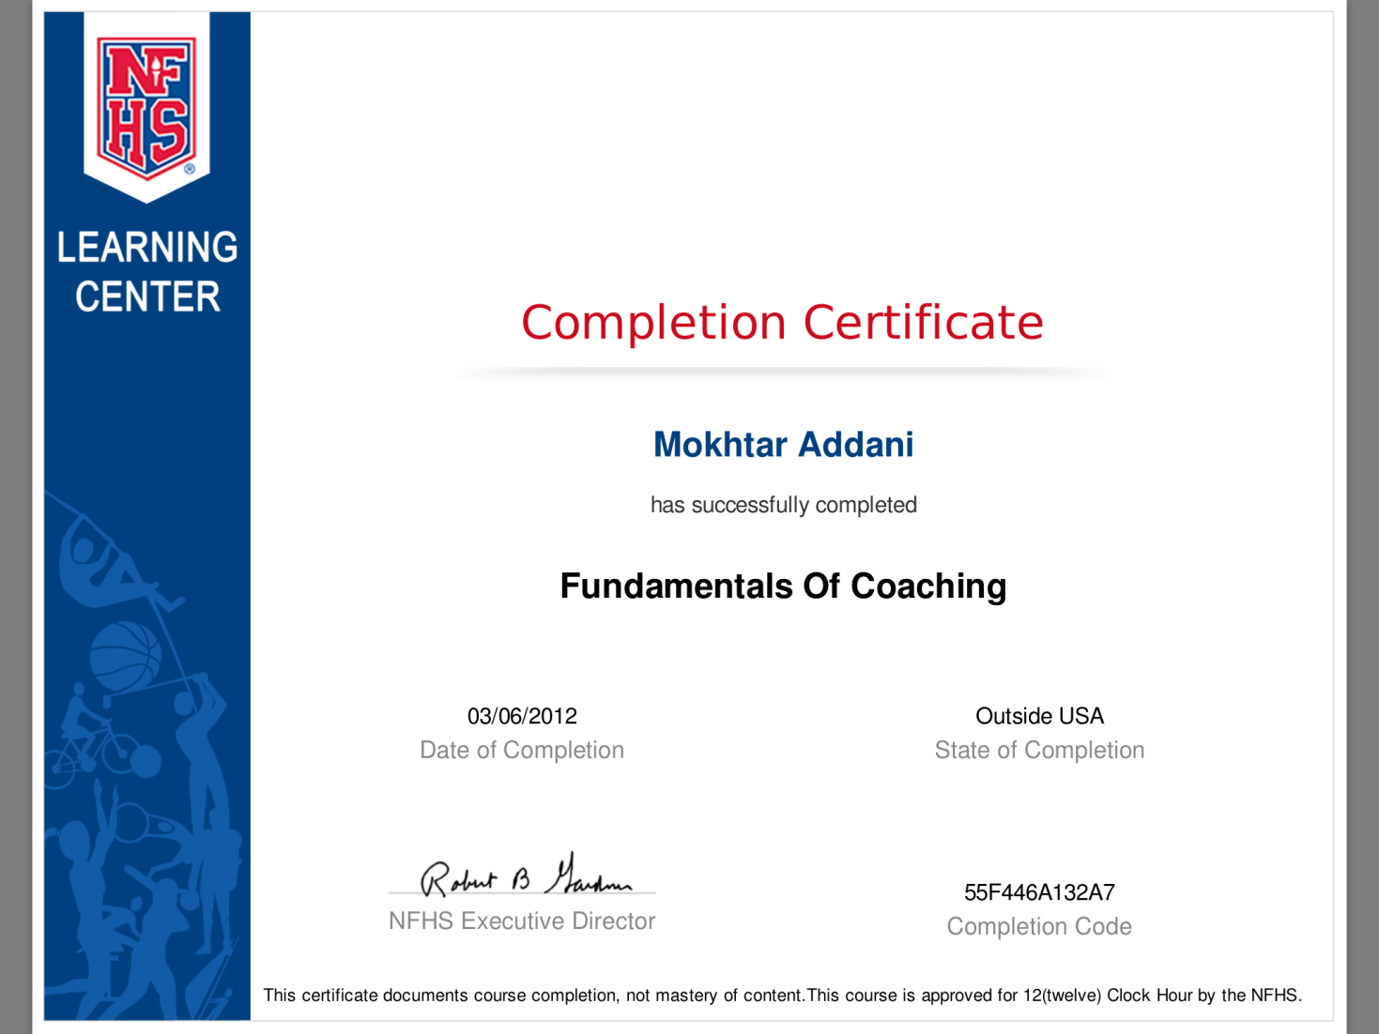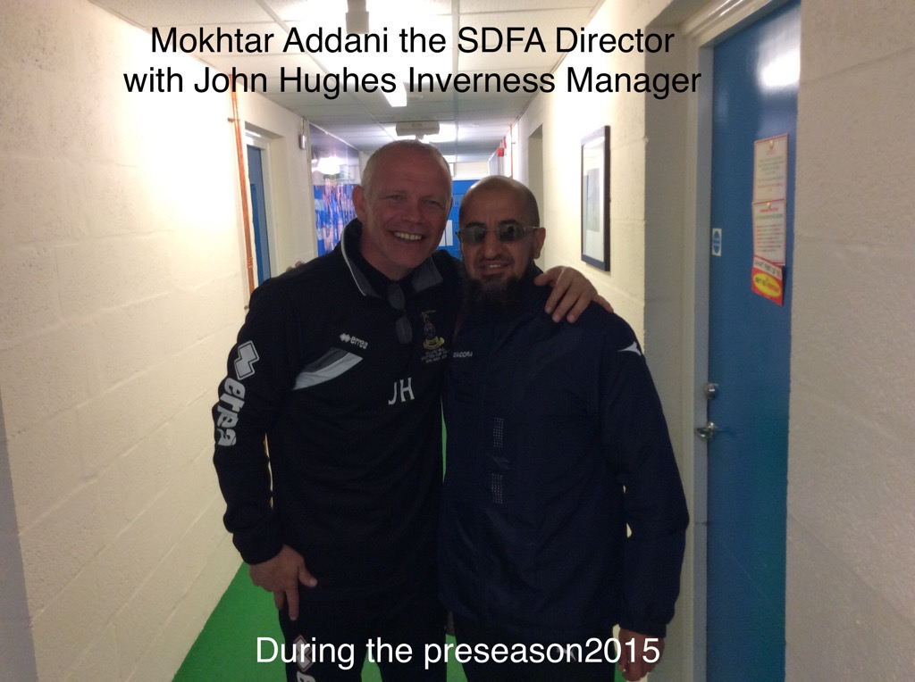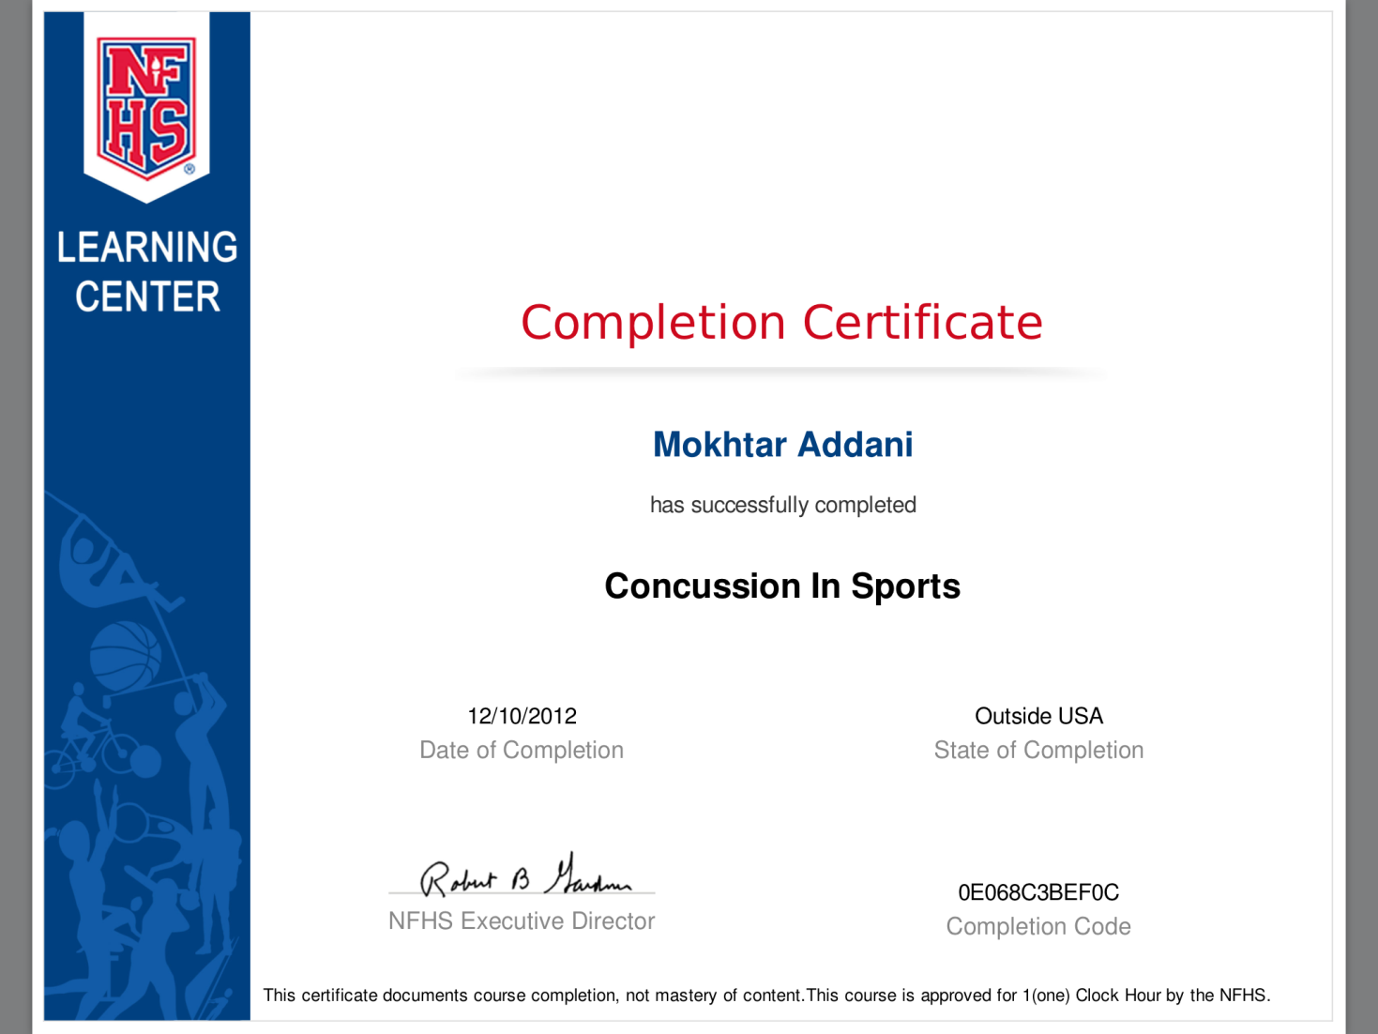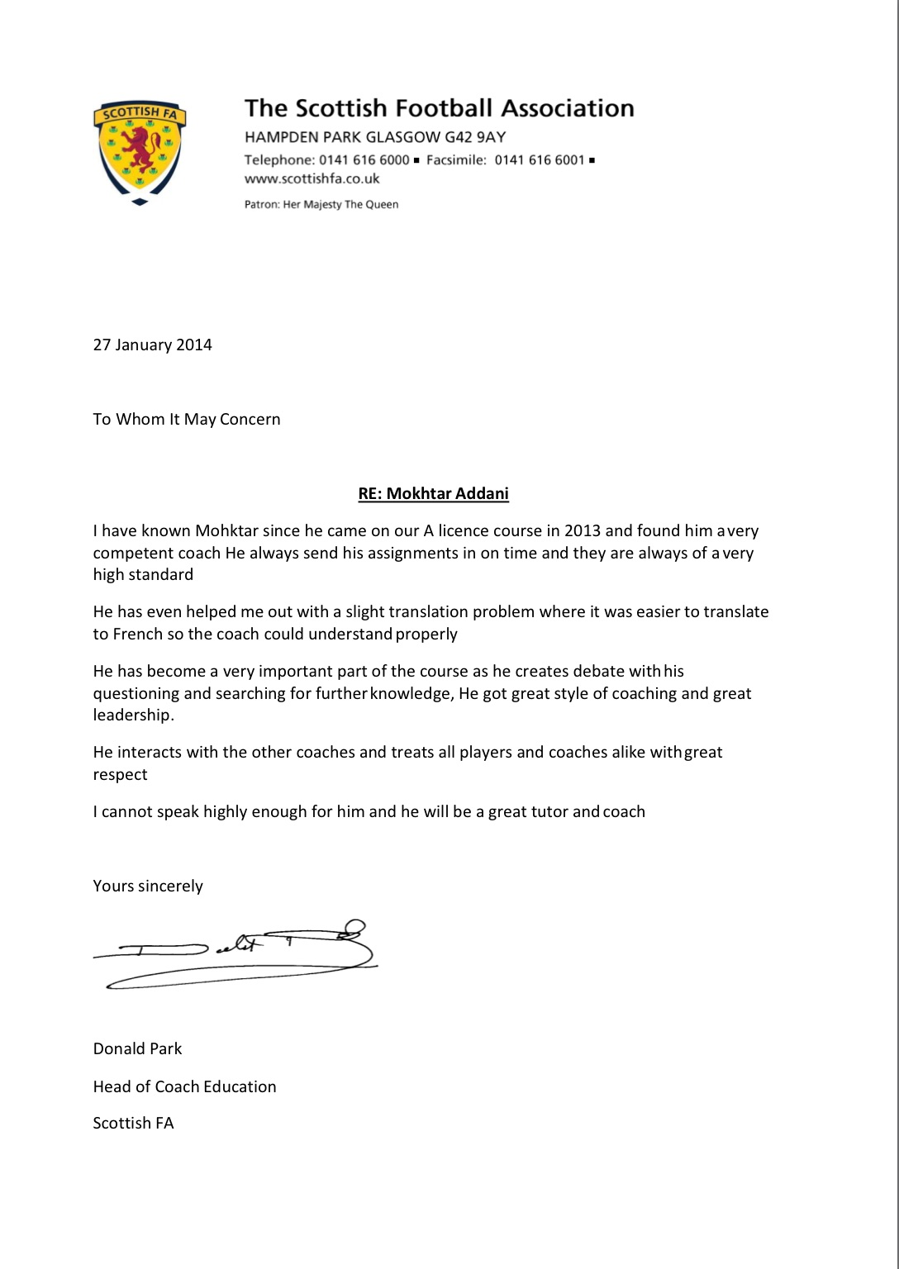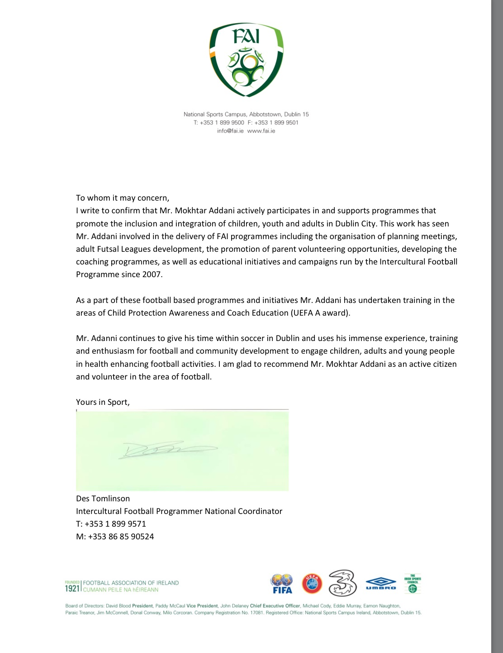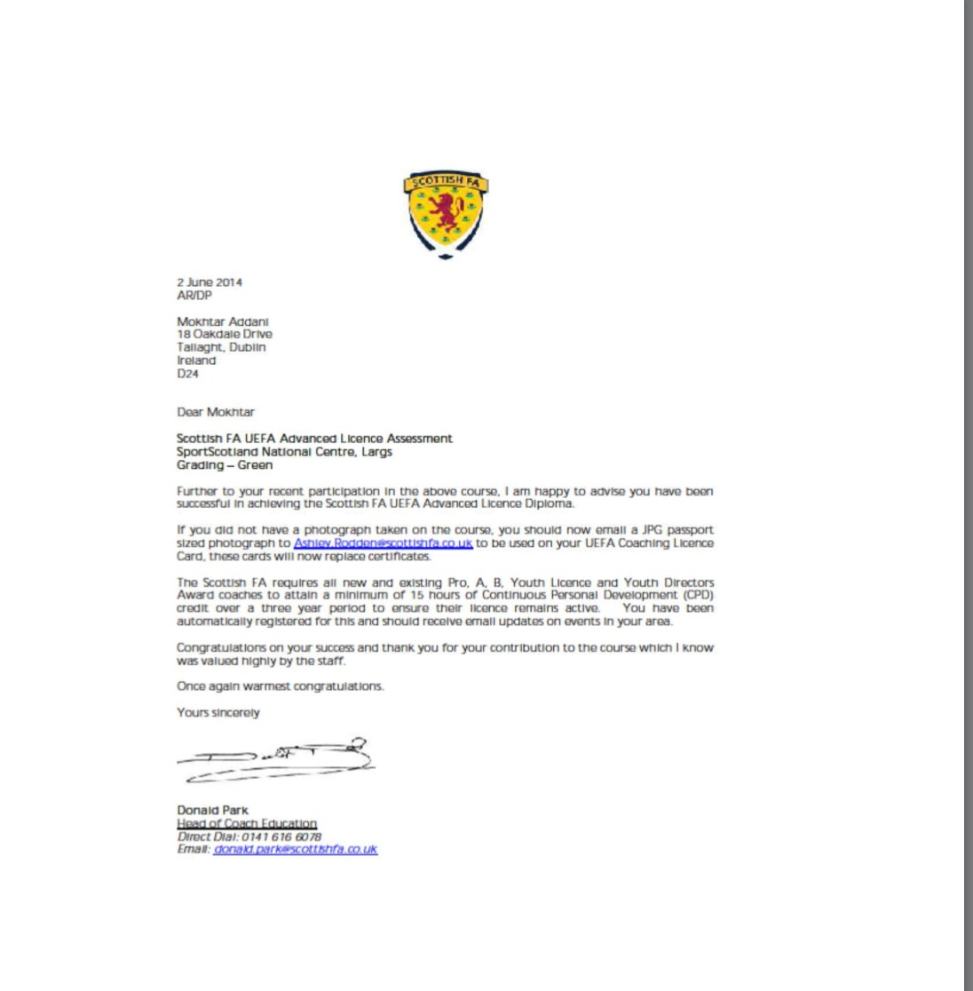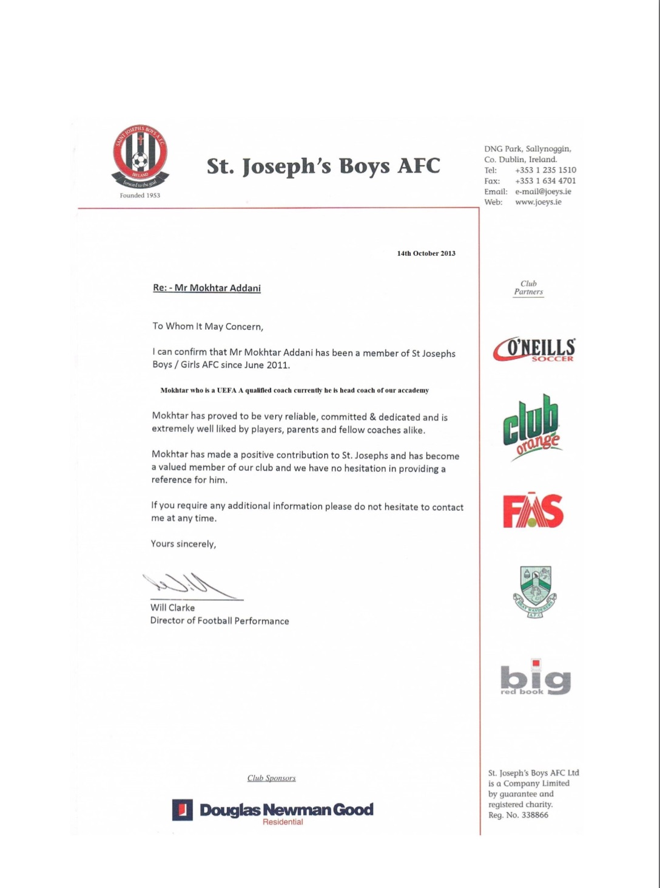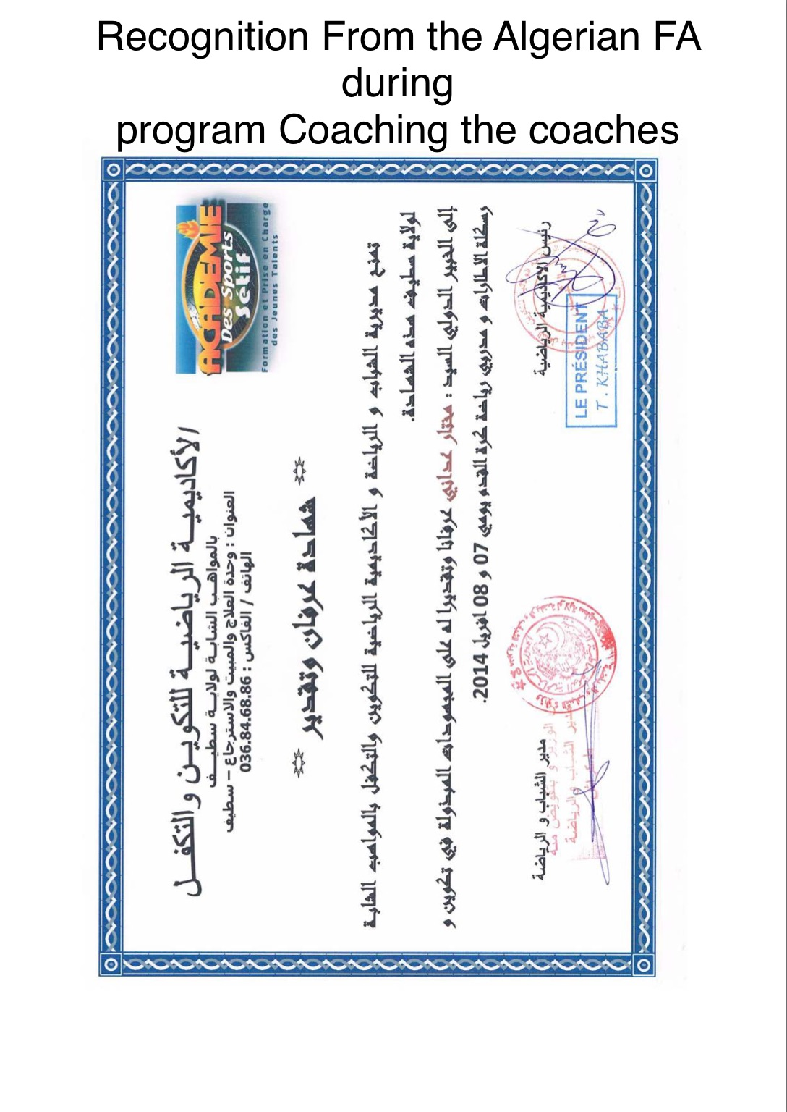

I did game analysis for the E-Setif Algeria, during the African cup Final and did setup the style of play for the team during the events and was part of the Continent Cup winning in 2014

Actual time working as Director of development with Wexford youth FC IRISH NATIONAL LEAGUE, And Director of the National League Football Academy

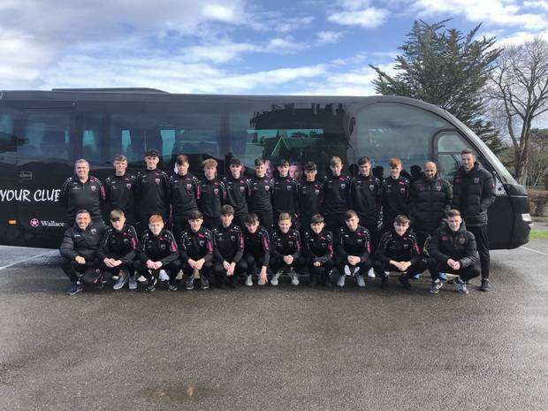

**Some of my Academy players**

**Ayman Ben Mohamed Tunisian National team now**

<http://www.extratime.ie/articles/16652/aymen-ben-mohamed-called-up-to-tunisia-squad/>

<https://www.buzz.ie/sport/how-this-irish-star-earned-an-african-cup-of-nations-call-111102>

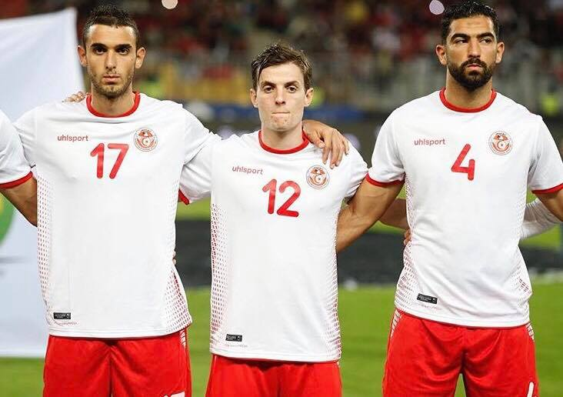

**James Furlong going to Fulham now**

<https://www.rte.ie/sport/soccer/2019/0623/1057041-furlong-set-to-join-fulham-from-shamrock-rovers/>

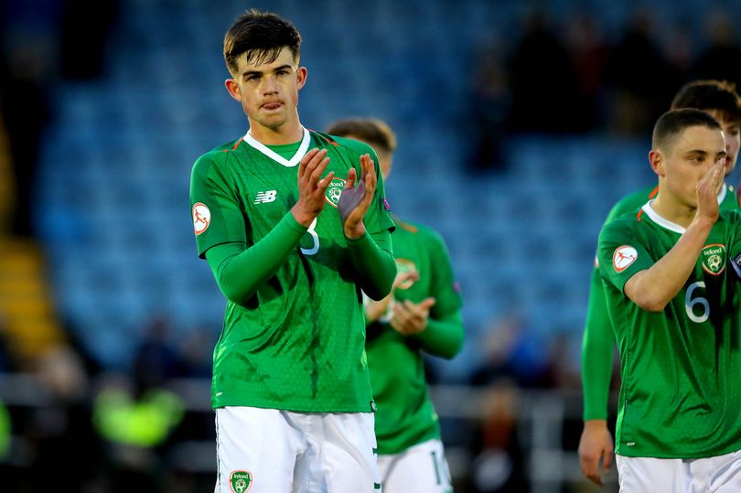

**Kaleem Simon**

<https://www.independent.ie/sport/soccer/league-of-ireland/simon-not-giving-up-hope-yet-34927694.html>



**References**

