CURRICULUM VITAE

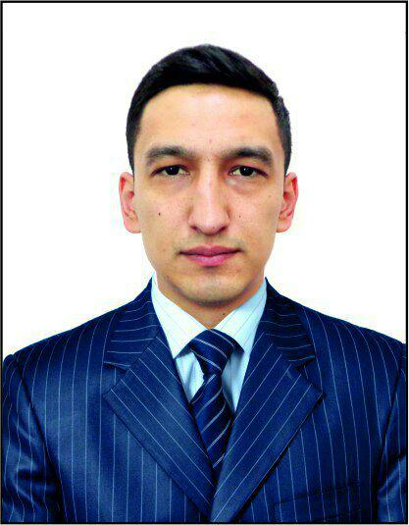 | Name | Bobur Alimardonov
 | Gender | Male
 | Nationality | Uzbekistan
 | Date of birth | 26/09/1992
 | Position in  Uzbekistan FA | Main specialist
CURRENT ROLES AND POSITION:
№ | Position/ Role | Organization | Period
1 | Main specialist at Technical Division | Uzbekistan Football Association | Since August 2018

EDUCATION: Period of study:

Tashkent chemical-technological institute | 2011-2015  Bachelor of Science in Nutrition
Academic Lyceum of the Tashkent State University of World Languages | 2008-2011  Philology (German)
AFC “C” License coaching course | 9-19/03/2019
AFC ”Fundamentals of Football Administration” | 28 October -01November 2019

LANGUAGES:

Language | Reading | Speaking | Writing
English | Fluent | Fluent | Fluent
Russian | Fluent | Fluent | Fluent
German | Good | Good | Good
Uzbek | Fluent | Fluent | Fluent

Football Career:

Clubs | Years
Football School №17 | 1999-2008
FC “Pakhtakor” B Team | 2009-2010
FC “Shaykhantakhur” First Division | 2011-2013
FC “Spartak Tashkent” First Division | 2014-2015
FC “Sergeli” Second Division | 2015-2016

WORKING EXPERIENCE:

Name of the organization | DEPARTMENT | POSITION | PERIOD
Uzbekistan Football Association | Technical Division | Main specialist | August 2018
LTD “Knauf” | Management | Sales manager | 11/2017 - 07/2018
LTD “Golden Art Build” | Management | Sales manager | 02/2016 - 11/2017
LTD “Unitel” telecommunication | Call center | Operator | 07/2015 - 01/2016

Courses:

Position | Name of the course | Year
Translator | AFC “PRO” Diploma coaching course | 11/2018-11/2019
Translator | AFC “Goalkeeping Level 1” coaching course | 11-16/03/2019
Translator | AFC “Fitness Level 1A” coaching course | 15-20/04/2019
Translator | AFC “Goalkeeping Level 2” coaching course | 6-12/06/2019
Coordinator | FIFA “Elite youth” seminar | 19-23/08/2019
Participant | AFC Fundamentals of Football Development Program | 28-10/01-11/2019
Participant | AFC Women’s Football Conference (Malaysia) | 19-21/11/2019

CONTACT DETAILS:

Phone number: +998712750131  Mobile: +99899848148 | Email: bobur-92fc@mail.ru  Home address: Sadoiy street, house 11, Uchtepa district, Tashkent, Uzbekistan  Linkedin: boburalimardonov

