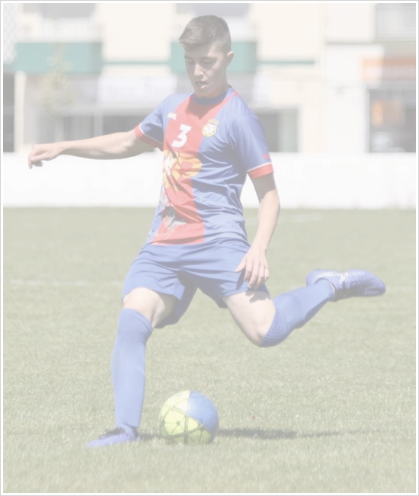**GIANCARLO FEDATTO**

Football Player

**Date of Birth**

07 June 2003

Nationality

**Brazilian / Italian**

Position

**Centre Back**

**Height**

179 cm

**Weight**

70 kg

**Main qualities**

Left footed, versatile, assertive, strong and fast player with a good mobility, technique and vision of game.

**Previous clubs**

Pulo do Gato Futsal | Brazil 2014

Mongo Football Club | Australia 2015 - 2018

Phoenix Futsal Club (NSW) | Australia 2017

Futebol Clube de Alverca | Portugal 2018 - 2019

**Achievements**

Champion of Sydney International Cup Under 14 - 2016

Champion of New Zealand International Tournament Under 15 - 2016

Sydney International Cup Under 15 - 2017

Champion of Football NSW Futsal Premier League Under 15 - 2017

**Contact details:**

Mauricio Fedatto

Phonen. +61 0452226057

Email: manaofedatto@hotmail.com