CURRICULUM VITAE
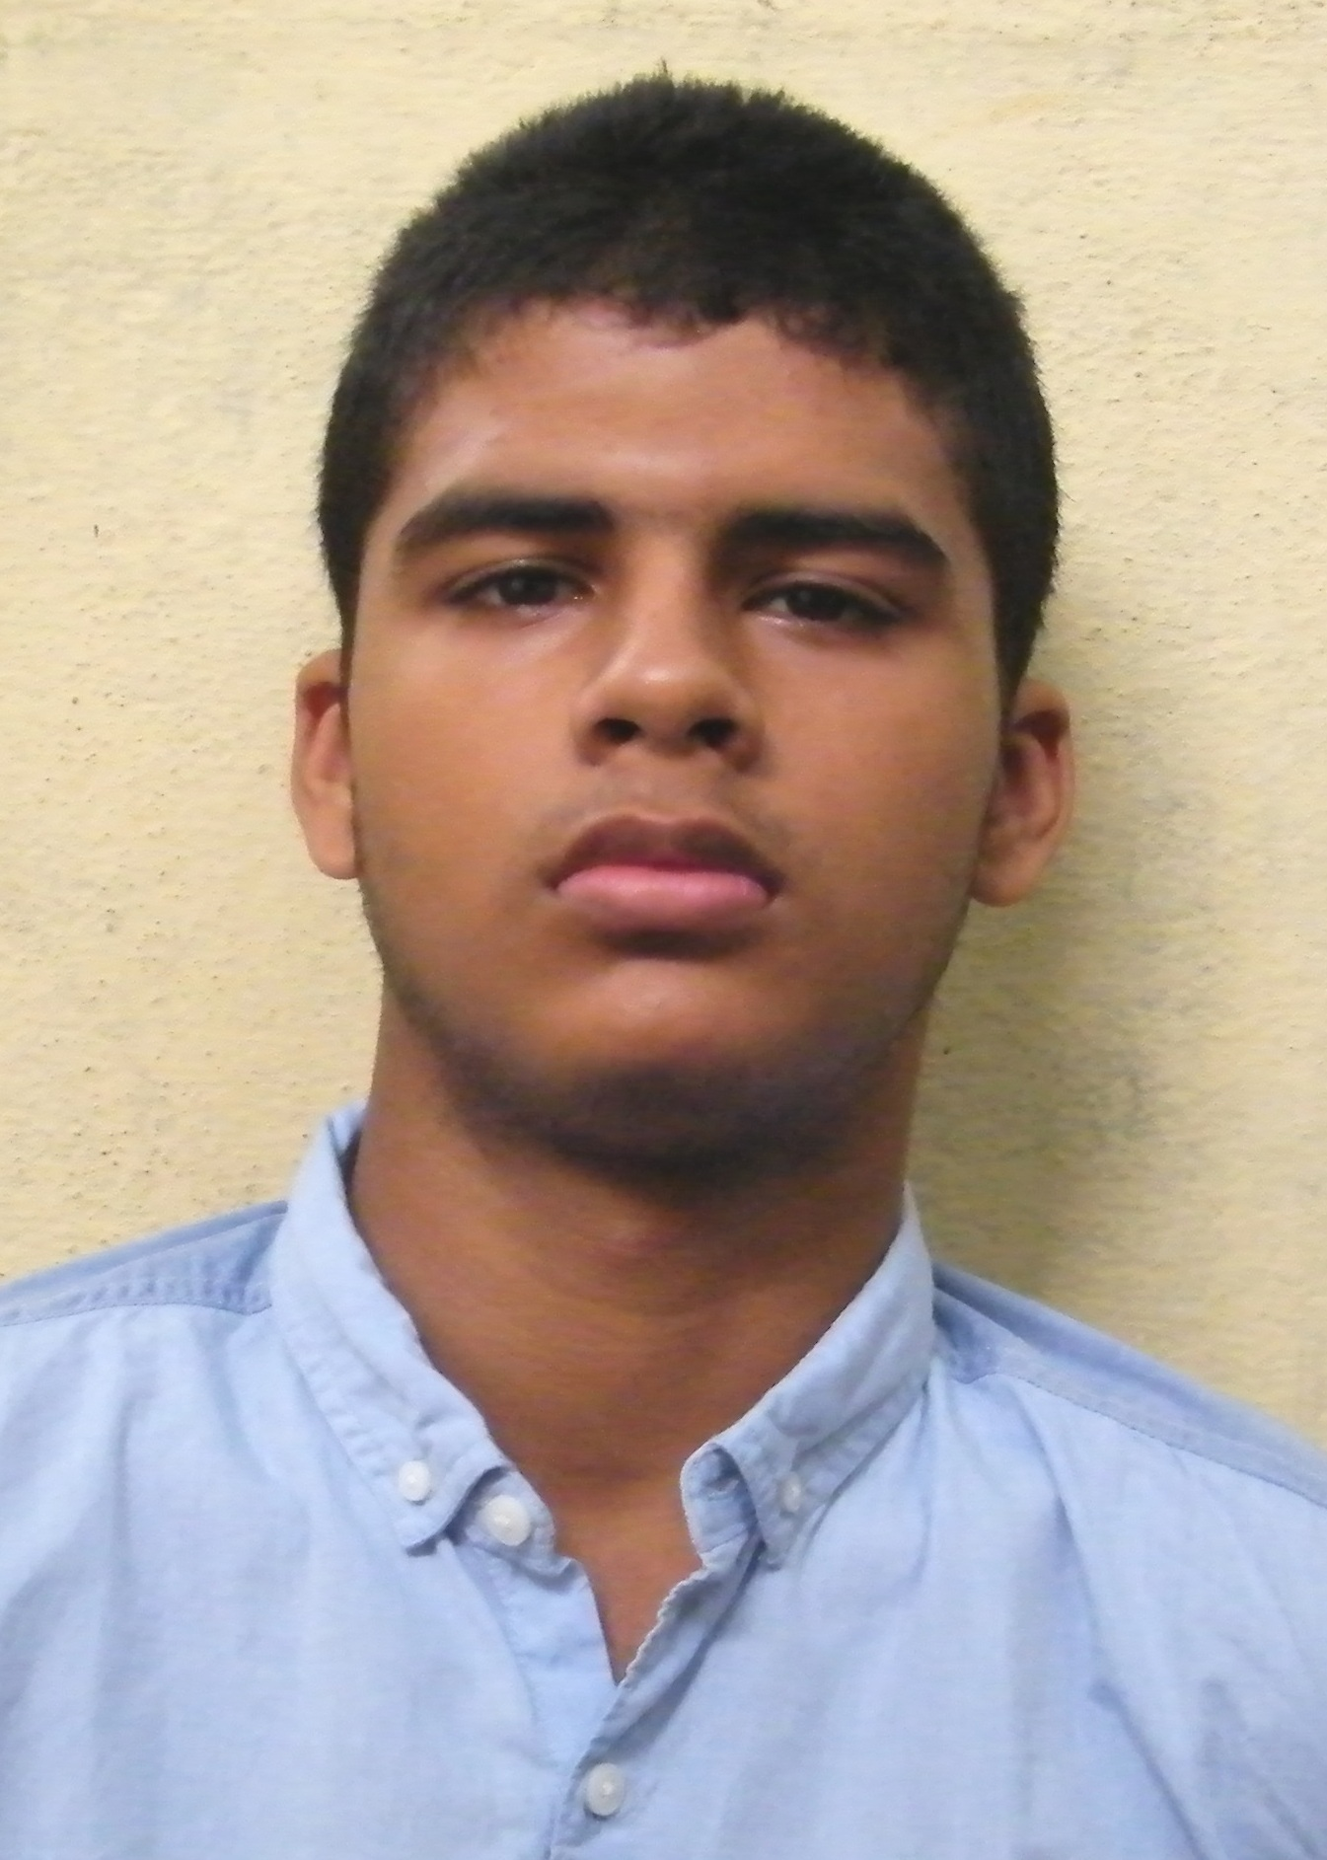
Vishnu chattopadhyay

CONTACT NO. : 7595843226
EMAIL ID : vishnugulmo@yahoo.com
ADDRESS : 86, Khanamudo, Rakkha Kali Tala,Janai,PIN – 700149.

CARRERE OBJECTIVES:
TO PURSUE A CHALLENGING CAREER AND BE A PART OF PROGRESSIVE ORGANIZATION THAT GIVES A SCOPE TO ENHANCE MY KNOWLEDGE AND UTILIZING MY SKILLS TOWARDS THE GROWTH OF THE ORGANIZATION.

ACADEMIC QUALIFICATION:
- SSLC examination under T.N.B.S.E IN 2014.
- HS (10+2 Science ) examination under Tamil Nadu State Board in 2016.
- BBA Sports Management under M.A.K.A.U.T in 2019.

EDUCATIONAL QUALIFICATION:
EXAMINATION | BOARD / UNIVERSITY | SCHOOL/ COLLEGE | YEAR | Marks secured
SECONDARY | T.N.B.S.E | N.S.N Group Of Schools | 2014 | 84/100
HS | T.N.S.B | Rosily.M.H.S.S | 2016 | 55/100
BBA  SPORTS MANAGEMENT | M.A.K.U.T | GEORGE COLLEGE | 2019 | 7.38/10

KEY SKILLS:
- Basic Knowledge in Computer.
- Good inter personal communication Skill.
- Good Public Speaking skills.
- Multiple years of experience of playing football.
- Fluent in English, Hindi, Bengali and Tamil.

INTERNSHIP:
- Worked as Marketing Manager at Urban Trainers, 2018 ( Bangalore).
- Worked as a Volunteer in Airtel Marathon 2018.(Kolkata).
- Worked as a volunteer at Leisure Sports Management 2018.(Kolkata).
- Worked as a volunteer at FIFA U-17 WC India -Mission 11 million- Stage-3 Football Festival 2017(Kolakta).
- Worked as Grassroots Coaching Intern at German Football Academy, 2019.

WORKING EXPERIENCE:
- Worked as an Assistant Coach In German Football Academy. 2019(Kolkata).
- Worked as Assistant Operations Manager at German Football Academy, 2019(Kolkata).
- Worked as a footballer at Evergreen Club Playing in the Calcutta Football League, 2019-2020(Kolkata).
- Working as Founder-director at Golzao sports management since 2020,Hooghly,

ACHIVMENTS;

- Won 3rd place in district level Science quiz Competition.
- Runners Up at state level Football Tournament.
- Runners up at Zonal Level School Football Tournament.
- Runners up at AFC grassroots day U-19 Football Tournament.

EXTRA CURRICULAR ACTIVITIES:
- Participated in multiple Football Tournaments at School and Club Level.
- Participated and Hosted various Seminars and events in college and school.
- Participated in various drama, quizzes, Project making competitions and debates in intra/inter-school and college level.

STRENGTH:
- Good Team Player.
- Hard Worker.
- Quick Learner.
- Positive Thinker.
- Easily adaptable to any situation.

HOBBIES:
- Reading Nutrition Related Articles.
- Watching Football.
- Playing Football.
- Reading articles about Fitness, training and conditioning.
PERSOAL DETAILS:
- FATHER’S NAME : Subhra Chattopadhyay
- DATE OF BIRTH : 15/07/1999
- GENDER : Male
- MARITAL STATUS : Unmarried
- NATIONALITY : Canadian(Overseas Citizen Of India)
- RELIGION : Hindu
- LANGUAGE : Hindi, Bengali, Tamil & English

DECLARATION

All the above information is true to the best of my knowledge. If any dispute/fabrication/moralistic information are found then I will be soul responsible for it.

(Vishnu Chattopadhyay)

Date & Place: Signature

