S.P.M.P. Soccer Player Management Program and Academy

**S.P.M.P.**

**President Jason Grant**

2635 Falmouth East Waterford St.Catherine Jamaica w.i.





**SOCCER PLAYERS MANAGEMENT PROGRAM and ACADEMY**

**S.P.M.P. TRAINING VIDEO EPISODE #1**

[**https://youtu.be/W66xj8sIkJ0**](https://youtu.be/W66xj8sIkJ0)

**S.P.M.P.** *was established by youth soccer development coach Jason O’Neil Grant in 2013, sighting that talented soccer players in Jamaica have limited opportunities and outlets to continue the development of their soccer careers to international standards. Hence the vision of developing players for the international market was born. There are thousands of exceptional soccer players who have become discouraged by the lack of opportunity here in Jamaica.*

*S.P.M.P. is the organization/Academy that will always put the player ‘s interest first. Players are selected and placed in grass root programs to adults between the ages of 10 years old to21 years old, combining youth and experience for a better and professional career in soccer.*

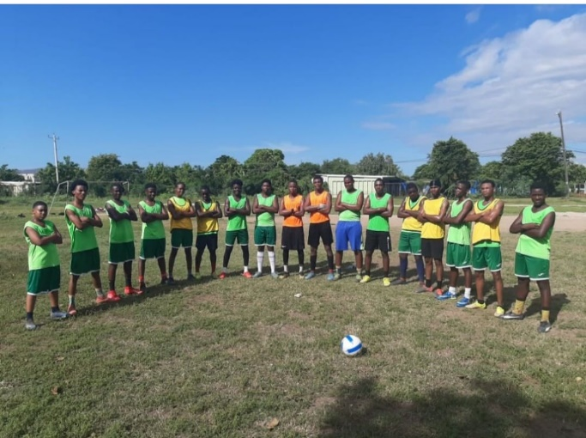  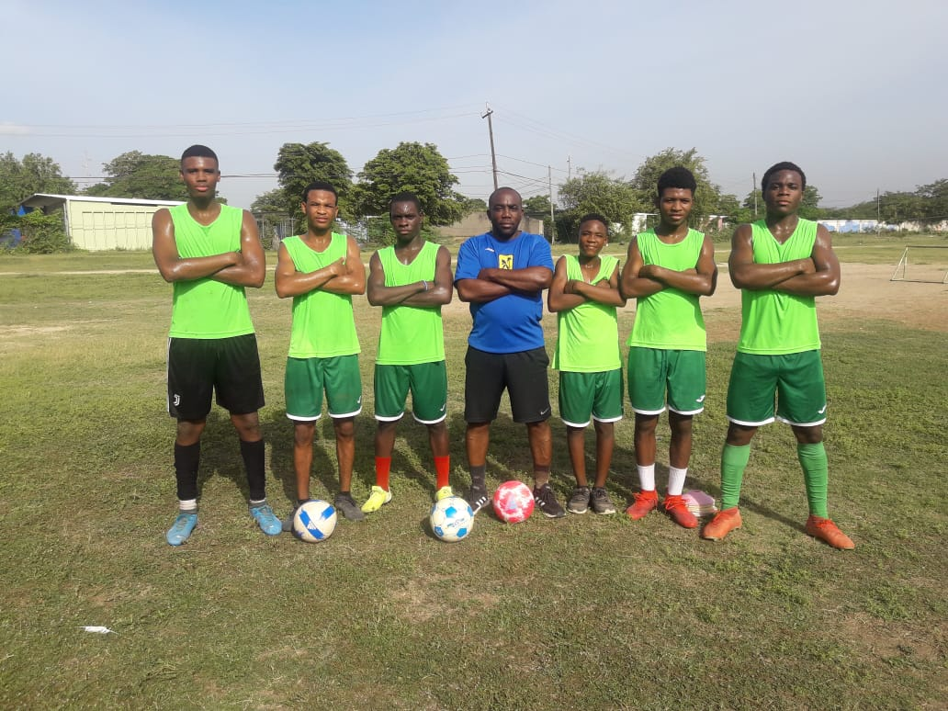

*S.P.MP. PLAYERS AT TRAINING Jason Grant S.P.MP. PLAYERS AT TRAINING*

*Our player management and soccer development programs aims to be compared to best standards in the global market as we observe, learn, practice and maintain the equivalent in our development training modules. Professionalism, discipline and teamwork are the basis on which we train and develop players.*

*Additional attributes which are focused on are personal confidence, persistence, consistent, game intelligence, communication (written and verbal), game knowledge, physical development, mental development, tactical and technical aspects just to name a few.*

***S.P.M.P. also caters to the needs of athletes from all fields of sports.***

*S.P.M.P.’s interest and obligation is to seek scholarships and professional employment for all player’s/athletes in the global football market working with agents, agencies, scouts from all territories globally, in EUROPE ,the Caribbean, USA, CANADA, UK, ASIA etc.*

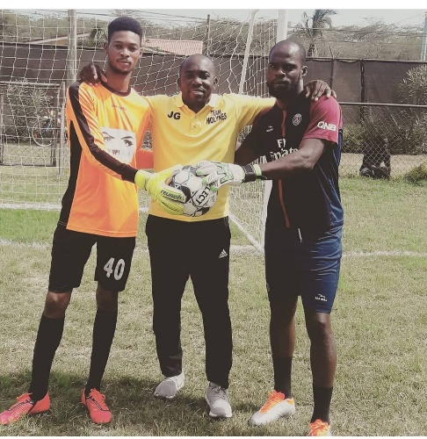  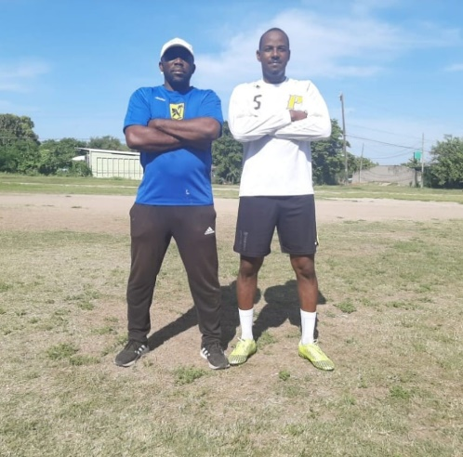 

*Jason Grant with Goal keepers Jason Grant/Garnet Garnet Jason Grant & staff member*

*In premiere league game Jamaica T.D. /Coach S.PM.P. At Molynes F.C.*

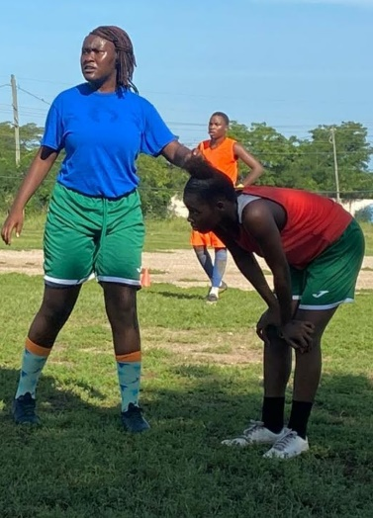 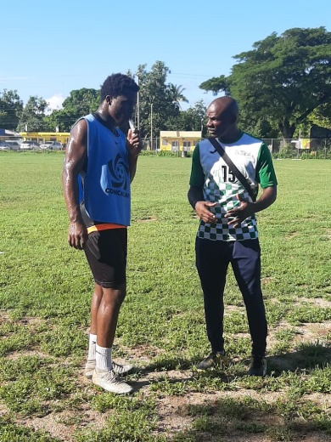 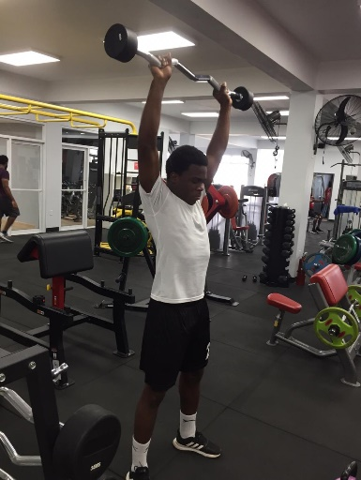

*S.P.MP. ladies in training S.PM.P player& coach S.P.M.P. Player in gym*

**

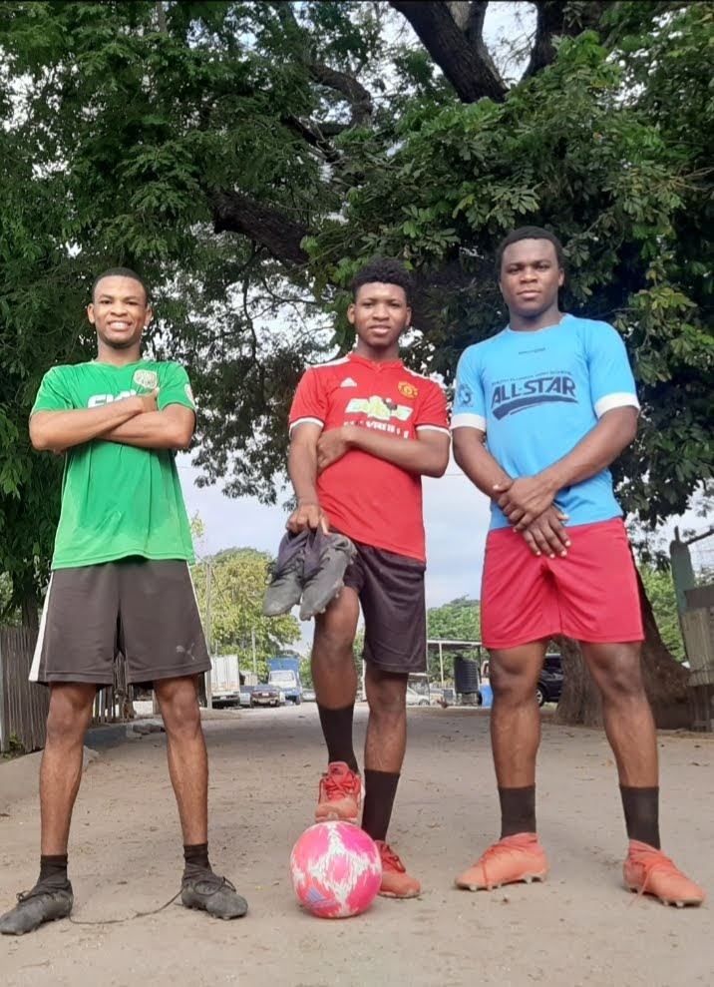

*S.P.M.P.PLAYERS AFTER TRAINING SESSION/PORTMORE JAMAICA*

*Rushane WILLIAMS19YO –#7#10#11, Rohan Beadle20YO #6#10 #8 and Dijon Grant 18YO #5,#4 #6*