**PRESENTATION**

I am a Hispanic-Brazilian coach. I am 52 years old and I have the UEFA PRO certificate. I have experience as a professional soccer player in Brazil, Spain and China; and as coach in Spain, Indonesia, Belgium, Jordan and Angola. I am married, and I have two children residing at Spain, in Region of Murcia.

Beginning of my career as coach: I started in the lower categories (from beginners to professionals), and I have the highest certification in UEFA PRO, which I studied in Spain.

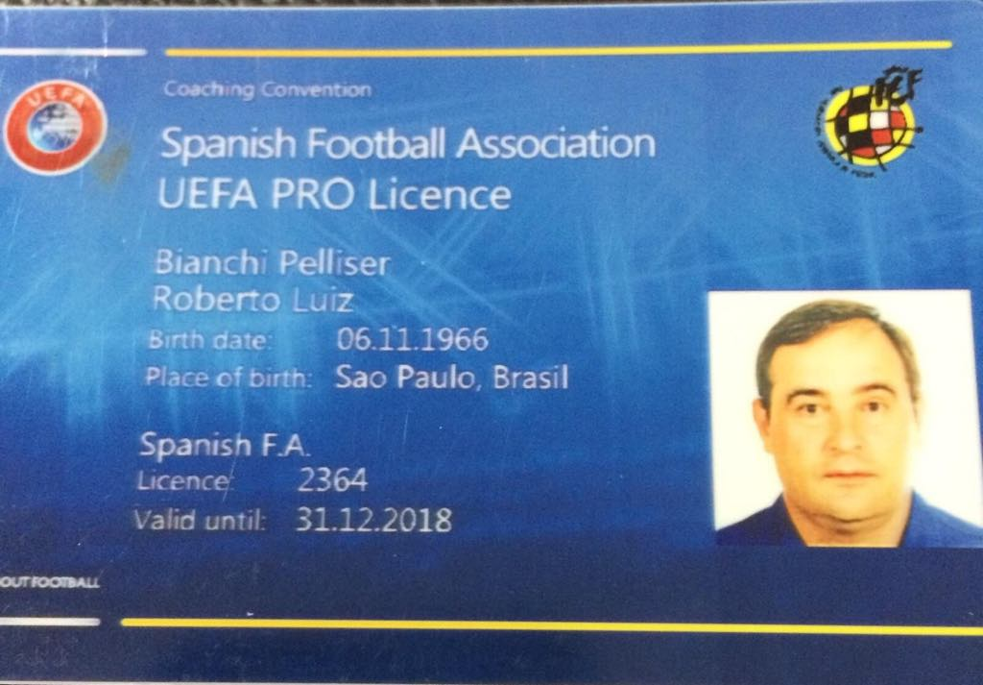

**INTERNATIONAL EXPERIENCE AS COACH**

After a few years coaching in Spanish Second Division, I had the opportunity of starting a new project through the Federación de Indonesia (Football Association of Indonesia). This project was designed for bringing the country new ideas and working methods (specifically the European method) for developing soccer in the country. I have been there for three years, and I have been champion in Second Division and coach of the Selección sub-23 (under-23 national team) of Indonesia. I have been also responsible of the change of the customs of the Indonesian players in the clubs in which I have coached –Pro Duta FC Second and First Division and Batavia Union First Division, – specially of their diet, achieving a great development in their physical performance. During my second year in the country, several players were called for the under-23 national team and the principal national team, due to their great change regarding their soccer culture regarding the tactical concepts and the competitive spirit (aspects very lacking in that country).

The project in which I participated in Belgium was different: a Russian businessman, owner of several business, bought a club in order to promote it to First Division in three years, with players of different nationalities. Unfortunately, this businessman disappeared during the second year.

We had great experiences in international matches against big clubs (like the Standard de Liège), as well as games against clubs from Austria and Romania.

My first experience in an Arabic club was in Jordan, where I was hired to avoid the relegation of an important club of the country, Shabab Al Ordon. When I arrived at the club, it was 10 points far from the salvation. After a lot of hard work and the establishment of an exigent discipline in the squad, I achieved the goal.

And now, here in Angola, I was hired two years ago to “recover” one of the biggest clubs of the country, Petro de Luanda. In the last nine years, this team couldn’t compete at a high level. After my arrival in 2016, we achieved two runners-up and we won the Copa de Angola (Angolan football Cup) in 2017. Currently we are in the second place and we have the possibility of winning. This excellent job was also possible thanks to the Federación Angola (Angolan Football Federation), who hired me to qualify the national team for the final stage of the CHAN 2018 (African Nations Championship). I achieved the goal given by the Angolan Football Federation while being coach of Petro de Luanda and national coach.

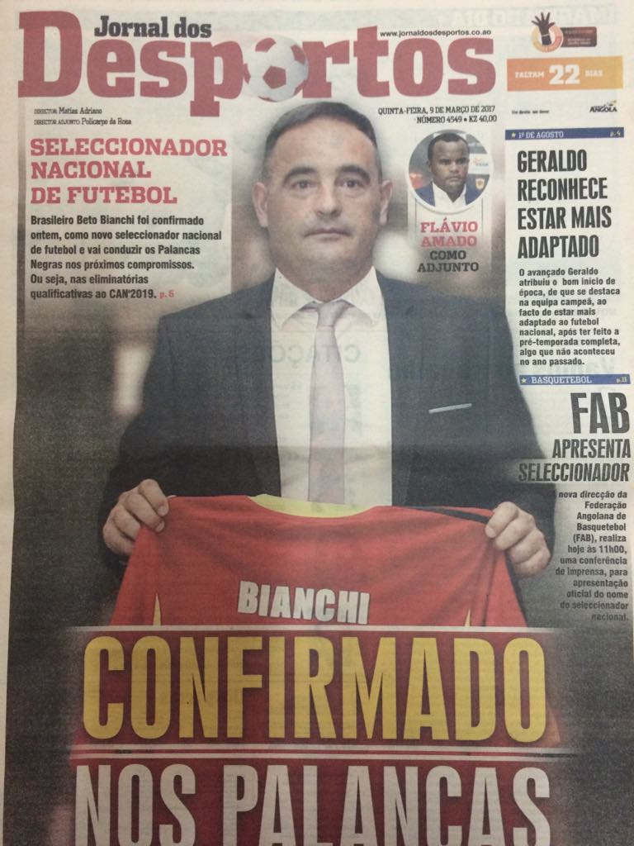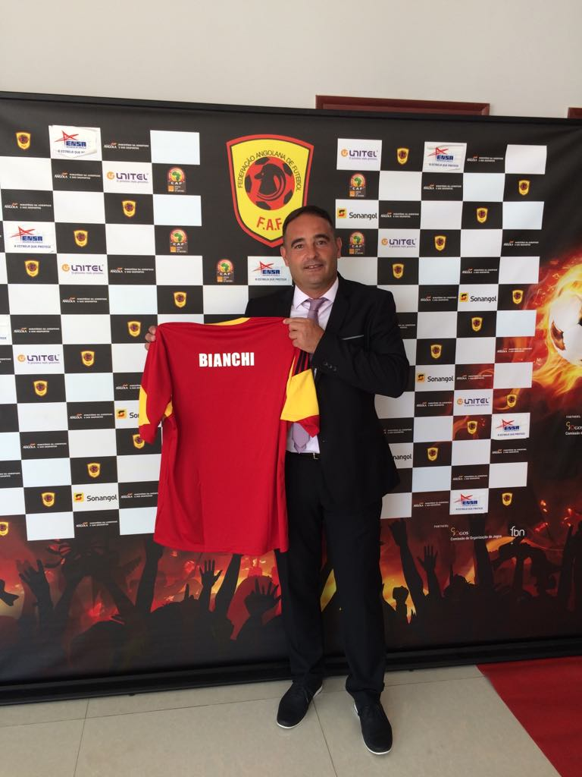

**MY PROFILE**

I have a strong and demanding character, I love discipline. I know the “life” inside a locker room, due to my period as professional soccer player. I can clearly transmit my demands to the players taking “the soccer language”. Despite the fact that I am very demanding, I am very close to the players and flexible when it is needed.

**METHODOLOGY**

I completed my training as coach all over Spain, where the Real Federación Española de Fútbol (Spanish Royal Spanish Football Federation) and the Colegio de Entrenadores (Spanish Coaching School) have a curriculum based on the methodology “Made in Spain”.

Each coach has its ideas about soccer, but they can be influenced depending on the soccer school you come from; the Spanish one, in my case. However, as you grow up, you get to know other soccer cultures and you can always learn something more and add it to your ideas.

My diary work on the soccer field is based on the work with the ball. The training encompasses the technic, tactic and physical parts, except during the preseason.

I work on the real situations that the players may face during a match, there is no situation in a match that they have not trained before. The training during the preseason is a “double-section training”, which during the season becomes a “single section” one, unless the situation requires changes in the squad for any reason detected by the staff. Sections last 1h15’ or 1h30’ and consist on training on the soccer field without breaks, stops and monotony. Everything is very intense and very similar to a high competition match rhythm, so that the player gets used to an intense game rhythm.

**GAME SYSTEMS**

From my point of view, game systems are very debatable. I think that the truly important aspect of soccer is that every player should know what to do on the soccer field and how to solve any problem during the game. A system can always change during the match, it depends on which team has the ball, where in the field are the teams playing, and the profile of your players.

During the preseason, I use three training systems: 1-4-3-3, 1-4-2-3-1 and 1-4-4-2. I like to have different options. I do not like improvisation, I think that everything should be perfectly planned and that we should always have a plan A, B and C. Matches and opposing teams provide us varied situations and we must be prepared to neutralize the opponent.

**MY TEAM’S PROFILE**

My team is tactically disciplined and very intense. I like to play under pressure, with good and fast ball movements, long but progressive ball possessions and an aggressive attack from the ¾ part of the opposite team’s field. They have a wide field of play and fast tackles through the touchlines.

**PLAYERS’ PROFILE**

There is a certain profile for each player in each position (it is part of the style of play that characterize my teams), but they can also adapt if they are not part of the squad. The system that we will use depends on this specific profile.

**IN CONCLUSION**

My teams have a well-defined style of playing the game. This style of play includes a game system which will be chosen depending on the profile of the players in the squad. Independent of the system used, it will not affect the style of play.

**HIGHLIGHTS**

Due to the excellent results last season in Petro de Luanda –runner-up of the League and winner of the Copa de Angola (Angolan football Cup)– and in Selección Nacional de Angola (Angola national football team) –placed in the final stage of CHAN (African Nations Championship) in Morocco in 2018– I have been elected as the best Spanish coach working outside Europe in 2017.

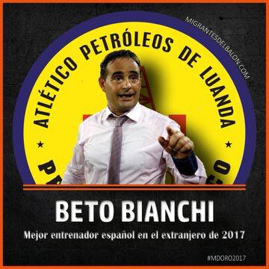CANDIDATES TO THE PRIZE WINNER OF THE PRIZE

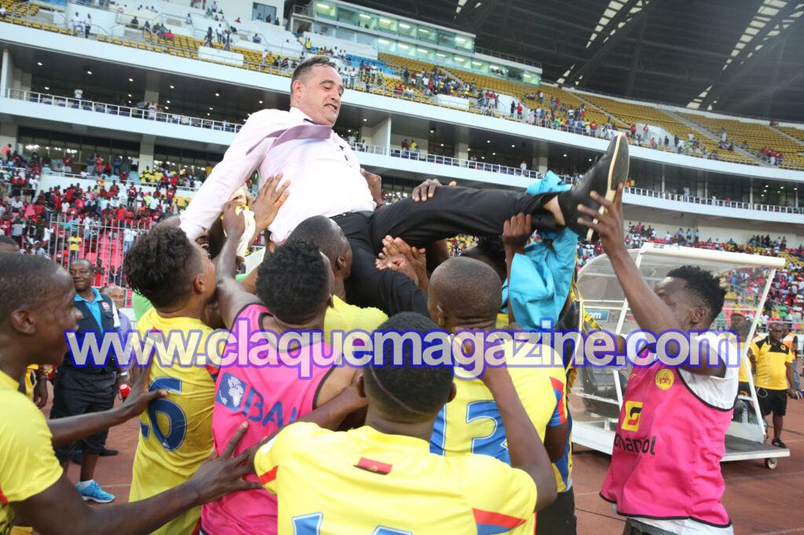

WINNER OF THE ANGOLAN FOOTBALL CUP 2017

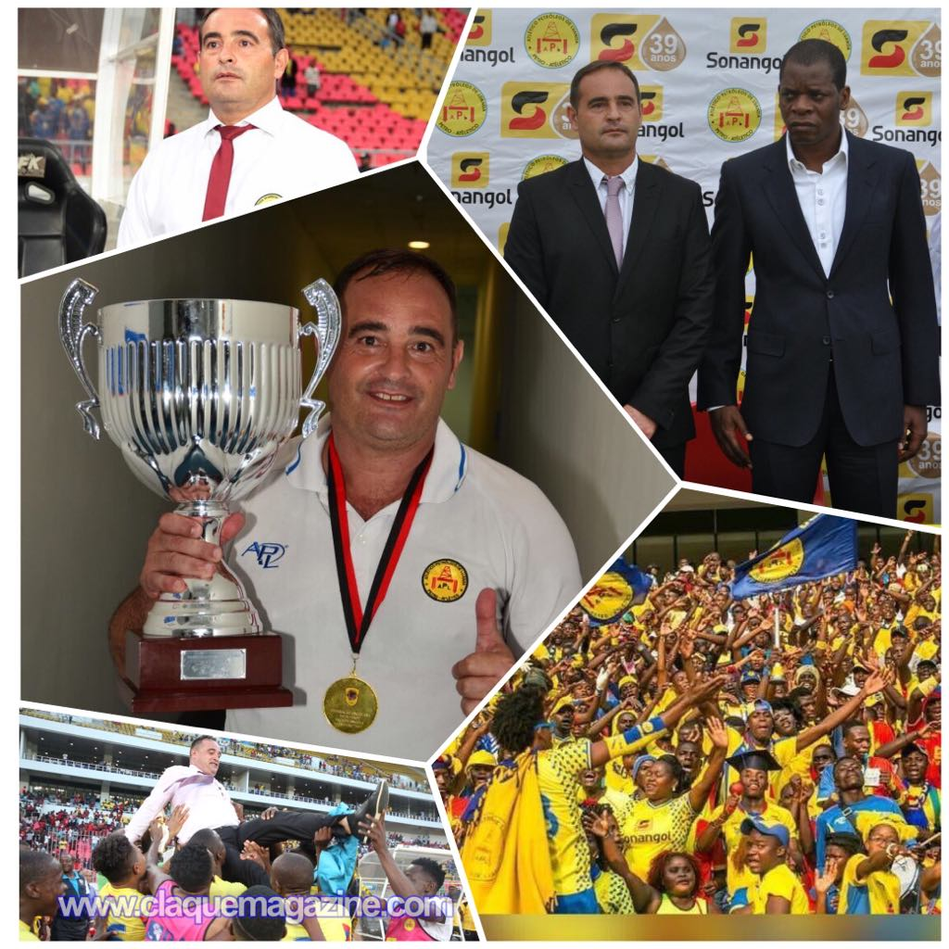

**INTERVIEWS VIDEOS AND MATCH SUMMARIES**

<https://www.youtube.com/watch?v=yvUKCU9mI6M>

<https://www.youtube.com/watch?v=cBmXtwl1JQQ>

<https://www.youtube.com/watch?v=g8GhqXAD_Js&feature=share>

<https://www.youtube.com/watch?v=5e99LueKtl8&feature=share>

<https://www.youtube.com/watch?v=nWuOwxMCae0&feature=share>

<https://www.youtube.com/watch?v=m0pIDg2YsQ0&feature=share>

**INTERVIEWS AND PHOTOS**

<https://onedrive.live.com/?authkey=%21ANxA1YCrBCLj0kE&id=66DEBC0D9DDEC56B%21317&cid=66DEBC0D9DDEC56B>

**SUMMARY OF RANKINGS OF SEASONS 2016, 2017 AND 2018 (until currently)**

**MORE THAN 70% EXPLOITATION**

